**Install DHCP server on CentOS 7**

Install DHCP server and client using the below command.

# yum install dhcp

Once the packages are installed, copy the sample configuration file to /etc/dhcp directory.

# cp /usr/share/doc/dhcp-4.2.5/dhcpd.conf.example /etc/dhcp/dhcpd.conf

Now, edit dhcpd.conf file.

# vi /etc/dhcp/dhcpd.conf

Define the subnet, range of IP addresses, domain and domain name servers as below:

[...]

**# Configuring subnet and iprange**

subnet 192.168.12.0 netmask 255.255.255.0 {

range 192.168.12.100 192.168.12.200;

option domain-name-servers 8.8.8.8, 8.8.4.4;

option domain-name "domain.com";

option routers 192.168.12.2;

option broadcast-address 192.168.12.255;

default-lease-time 600;

max-lease-time 7200;

}

[...]

For fixed IP:

host mywindows-client {

hardware ethernet 00:0C:29:05:A7:CB;

fixed-address 192.168.12.110;

}

Now, start the dhcpd service and make it start automatically on system reboot.

# systemctl restart dhcpd

# systemctl enable dhcpd

If you face any issues in restarting the DHCP service, then consider updating the SELinux context or **disable SELinux permanently on CentOS 7 / RHEL 7**.

/sbin/restorecon -v /etc/dhcp/dhcpd.conf

That’s it. Now, skip to ‘[**Configure DHCP Clients**](https://www.itzgeek.com/how-tos/linux/ubuntu-how-tos/install-and-configure-dhcp-server-on-centos-7-ubuntu-14-04.html#clients)’ section and configure your clients to get IP addresses automatically from the DHCP server.

**Install and Configure NTP Server and Client on Centos 7**

**Set up NTP Server on Centos 7**

First, you need to update your local package index with the following command:

yum update -y

Then, you can install NTP packages on Centos 7 with the following command:

yum install ntp -y

At this point, you need to configure the NTP server. To add NTP Server information in /etc/ntp.conf, you need to open the file with your favorite text editor, here we use vi:

vi /etc/ntp.conf

You need to provide the NTP Server IP or hostname with the server keyword. You can also add the Server information at the end of the file.

# For more information about this file, see the man pages

# ntp.conf(5), ntp_acc(5), ntp_auth(5), ntp_clock(5), ntp_misc(5), ntp_mon(5).

driftfile /var/lib/ntp/drift

# Permit time synchronization with our time source, but do not

# permit the source to query or modify the service on this system.

restrict default nomodify notrap nopeer noquery

# Permit all access over the loopback interface. This could

# be tightened as well, but to do so would effect some of

# the administrative functions.

restrict 127.0.0.1

restrict ::1

# Hosts on local network are less restricted.

#restrict 192.168.1.0 mask 255.255.255.0 nomodify notrap

# Use public servers from the pool.ntp.org project.

# Please consider joining the pool (http://www.pool.ntp.org/join.html).

server 0.centos.pool.ntp.org iburst

server 1.centos.pool.ntp.org iburst

server 2.centos.pool.ntp.org iburst

server 3.centos.pool.ntp.org iburst

When you are done, save and close the file.

If you want to restrict the NTP Server access for some of the clients, you can edit the /etc/ntp.conf file and replace the network information with the client network and their subnet mask information. This will restrict the given Client access.

restrict 192.168.1.0 mask 255.255.255.0 nomodify notrap

Now restart your NTP service on Centos 7 with the command below:

systemctl restart ntpd

Enable your NTP server to start on boot on Centos 7:

systemctl enable ntpd

Next, you can check your NTP Synchronization Status with the following command:

ntpq –np

Output

remote refid st t when poll reach delay offset jitter

==============================================================================

*91.216.151.61 131.130.251.107 2 u 3 64 1 4.126 -1.069 2.578

162.159.200.1 10.50.9.36 3 u 2 64 1 0.327 -0.593 0.092

2a00:ff0::19 36.224.68.195 2 u 1 64 1 49.357 -0.264 1.640

86.127.71.168 115.75.236.158 2 u 2 64 1 5.637 -1.318 0.178

If everything went well then Your date and time should be synchronized from the NTP Server on Centos 7. You can verify your timezone with the following command:

timedatectl

Output

Local time: Sat 2022-04-16 03:36:54 EDT

Universal time: Sat 2022-04-16 07:36:54 UTC

RTC time: Sat 2022-04-16 07:36:53

Time zone: America/New_York (EDT, -0400)

NTP enabled: yes

NTP synchronized: yes

RTC in local TZ: no

DST active: yes

Last DST change: DST began at

Sun 2022-03-13 01:59:59 EST

Sun 2022-03-13 03:00:00 EDT

Next DST change: DST ends (the clock jumps one hour backwards) at

Sun 2022-11-06 01:59:59 EDT

Sun 2022-11-06 01:00:00 EST

If you want to query from NTP Server and check the current offset and delay, you can use the command below. For example:

ntpdate -q pool.ntp.org

Output

server 162.159.200.123, stratum 3, offset -0.001746, delay 0.02603

server 86.127.71.168, stratum 2, offset -0.002588, delay 0.03148

server 93.190.144.28, stratum 2, offset -0.001501, delay 0.02661

server 162.159.200.1, stratum 3, offset -0.001788, delay 0.02602

16 Apr 03:37:34 ntpdate[30123]: adjust time server 93.190.144.28 offset -0.001501 sec

**Install and Configure NTP Client**

At this point, you can install the NTP on your Client’s machine. Here our client machine is Centos.

Install your NTP client with the command below:

yum install ntp

Then, configure your ntp.conf file and point to your NTP server:

vi /etc/ntp.conf

server your-server-ip-address

When you are done, save and close the file.

Next, restart your NTP client:

service ntpd restart

Test your NTP client status whether properly configured or not by running the below command:

ntpq -p

**Install Apache Web Server**

**1.** First update the system software packages to the latest version.

# yum -y update

**2.** Next, install Apache HTTP server from the default software repositories using the [YUM package manager](https://www.tecmint.com/20-linux-yum-yellowdog-updater-modified-commands-for-package-mangement/) as follows.

# yum install httpd

Install Apache on CentOS 7

**Manage Apache HTTP Server on CentOS 7**

**3.** Once Apache web server installed, you can start it first time and enable it to start automatically at system boot.

# systemctl start httpd

# systemctl enable httpd

# systemctl status httpd

Start and Enable Apache

**Configure firewall to Allow Apache Traffic**

**4.** By default, CentOS 7 built-in firewall is set to block Apache traffic. To allow web traffic on Apache, update the system firewall rules to permit inbound packets on **HTTP** and **HTTPS** using the commands below.

# firewall-cmd --zone=public --permanent --add-service=http

# firewall-cmd --zone=public --permanent --add-service=https

# firewall-cmd --reload

Configure firewalld to Allow Apache

**Test Apache HTTP Server on CentOS 7**

**5.** Now you can verify Apache server by going to the following URL, a default Apache page will be shown.

http://SERVER_DOMAIN_NAME_OR_IP

[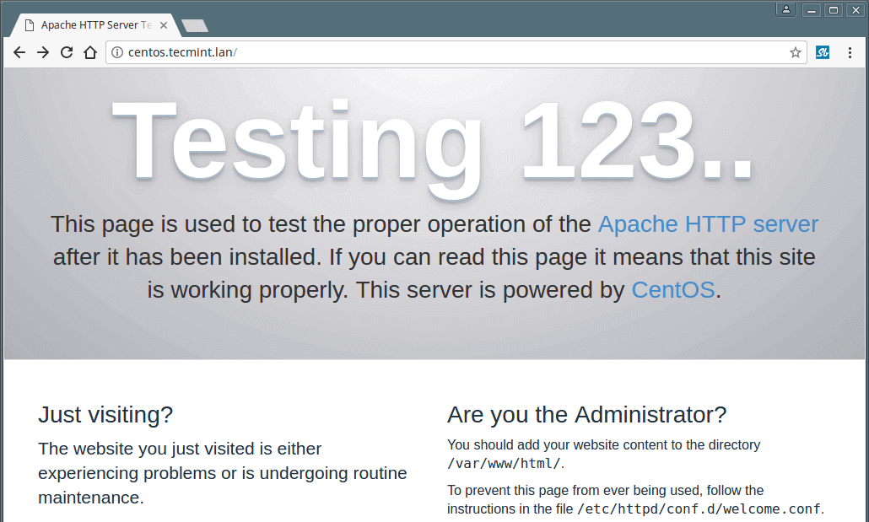](https://www.tecmint.com/wp-content/uploads/2017/07/Default-Apache-Welcome-Page-on-CentOS-7.png)

Default Apache Welcome Page